Vision
Institution
Name

Abstract
In this paper, information about what makes up the eye as well as its functions will be emphasized. The neurons in the retina, the function of the cornea and the other layers will be discussed. Also, it will cover details about the various disorders. Some of these disorders can be treated whereas others cannot be treated. Such disorders includes the optic nerve atropy, achromatopsia, cataracts, astigmatism, myopia and hyperopia. The paper will also tackle the way mental health and vision impairments are linked. The eye and the brain communicates in order to differentiate shapes, sizes and images. Perception together with cognitive work hand-in-hand to assist individuals to recall what they have ben viewing or assist them comprehend what they are currently viewing.

Introduction
The eyes are considered to be complex organs in the human body. The eye comprises of three different layers. These layers making up the eye are the inner layer, the middle layer and the outer layer. Each of the listed layers of the eye is thought to be having its unique function. The eyes allows light to pass through-in order to be able to view an object. The eye receives colors to assist in differentiating the image that is been viewed at any given time (Apus Bright Space, 2021). Once the image has been received in the eye, perceptual-cognition starts to occur. If, for instance, a person has a visual impairment, cognition-perception will not be working effectively. Examples of these visual impairment been mentioned above are shortsightedness, long-sightedness, and astigmatism. However, a person should not get worried so much because of these sight impairments since they can be corrected using corrective lenses (In Bishop, & In Martin, 2014). However, it does not mean the above listed sight impairments are the only ones, there are other visual impairments which include; optic nerve atrophy, achromatopsia and cataracts.
Physiological Underpinnings
There are three layers making up the eye. These three layers include; the inner layer, the middle layer and the outer layer. The eye has a transparent outer layer which is referred to as the cornea. The cornea is situated at the front of the eye. The cornea is used to assist an individual’s eye focus light. Once the light has been focused, it becomes possible for the individual to see things in a clear manner (El, 2019). The cornea has a dome-shape which makes it possible to bend light in order to assist the eye to concentrate light. This is also the part of the eye that covers the iris and the pupil. Some of the key kind of cornea conditions are dry eye, keratitis, allergies and injuries (Apus Bright Space, 2021). The listed conditions affects the cornea and hence irritates the eye, hence, causing sight issues. The white part of the eye is referred to as the sclera. Sclera is the opaque, tough, fibrous and protective part of the eye that is attached to the cornea. The primary function of the sclera is to provide protection.
Structure
The inner part of the eye is composed of the layers of neurons and the retina. It is the retina that captures the light that enters the eye. When the light has been captured by the retina, it is transferred to the cones and rods. Cones and rods are the neurons that are situated in the inner part of the eye. These neurons that are located in the inner layer of the eye are referred to as ganglion cells and photoreceptors. Rods and cones are what makes up the photoreceptors (In Bishop, et al., 2014). These cones and rods are the ones that are responsible for turning light and color into an electric signal which is then directed to the occipital lobe part of the human brain.
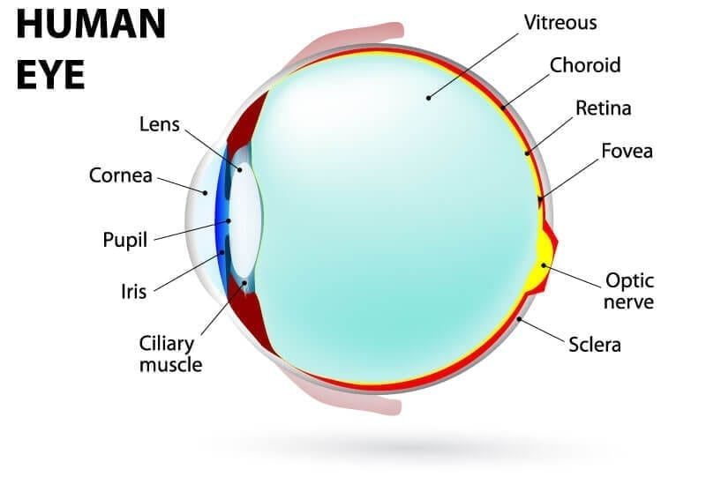
Image curtesy of life biology
The middle layer of the eye is made up of ciliary body, choroid and iris. It is the iris that assist the eye in controlling the amount of light that enters in. Whenever the human eye comes into contact with bright light, the iris closes the pupil to prevent light from entering. Thus, the pupil should only permit less amount of light to enter. On the other hand, when here is less light the iris open the pupil wide to allow sufficient or lighter to enter. The choroid is the part that consists of blood vessels which covers the rear section of the eye (In Bishop, et al., 2014). This part is sandwiched between the sclera and the retina. In addition, the ciliary function is to assist the lens to focus and it contains muscles.
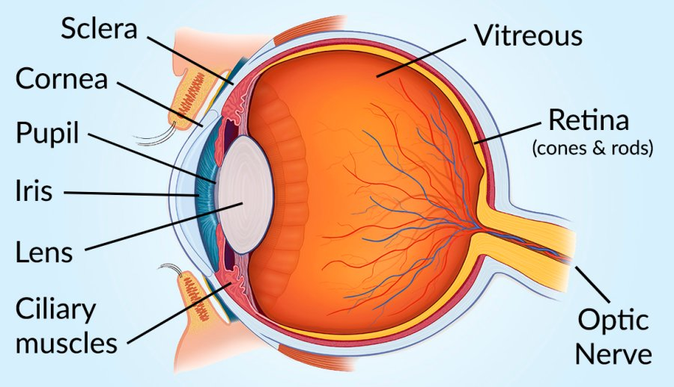
Image curtesy of biology of life
Function
The main function of the eye is to provide vision. The eye is capable of receiving light and consequently process the image that is in sight to help in vision. Once the eye detects light it permits it to pass through the pupil after which it is translated into electro-chemical impulses in the neurons. Light enters the eye through the cornea which is the equivalent of a camera lens. The lens of the human eye is situated behind the iris. The iris is the part of the eye that is used to focus light onto the retina. The eyes regulates the amount of light that enters. This function is achieved through the contraction and expansion of the iris (El, 2019). The iris contacts in the event that the eye happens to have come into contact with bright color. Consequently, the iris expands hence opening the pupil to allow more light when the eye comes in dim light.
In addition, another function of the eyes is to produce tears. Tears are useful to the eye as they wash away any debris that could have got stuck on the outer part of the eye. Tears also nourishes as well as lubricates the eyes (Noë, & Thompson, 2002). Tears which are in healthy condition comprises of substances such as mucus, water and oil which are produced by some glands located in the eye.
At times the eye could be diagnosed with some conditions which might negatively impact their functioning. Some of these conditions might comprise of astigmatism, shortsightedness and long-sightedness. Astigmatism takes place in the event that the eyeball and the cornea are not shaped correctly (Noë, et al., 2002). They can be more oval or more round. Their actual shape is supposed to be doom-like. Shortsightedness which is also referred to as myopia takes place when the eyeball is too long. In addition, long-sightedness which is also referred to as hyperopia takes place when the eyeball happens to be shorter than normal (In Bishop, et al., 2014). However, people who happen to be experiencing any of the above sight conditions ought to worry not because they can be treated using contact or corrective lenses.
There are also other diagnoses of the eye issues which include; the optic nerve atrophy, achromatopsia and cataracts. Achromatopsia takes place when an individual experiences difficulties in differentiating colors which could be caused by malformation as well as limited to total absence of cones. The cataract condition takes place when the crystalline lens appears to be cloudy (Apus Bright Space, 2021). The optic nerve atrophy is a condition that occurs when the eye experiences challenges in translating light into electrical impulses.
Psychological Underpinnings
Different individuals undergo different things whenever they are experiencing vision impairment. Whenever the elderly persons within the society is having visual impairment, they can easily experience depression due to lack of socializing. They might think that they no longer matter in the community. In addition, they might also undergo denial or depression as they try to cope with their prevailing visual condition (El, 2019). Visual impairment to any person of any given age, be it old, young or middle age, can be traumatic and it can get worse in the event that these persons gets to notice that they are not receiving any support. This conditions can in the long-run prove to be harmful to these persons and even the society at large.
Cognitive-Perceptual
Cognition and perception are tied together when it comes to vision. Cognition refers to the knowledge that a person is already consuming that leads to shaping his or her decision. Perception is the one that directs an individual’s choice. Three steps are completed during visual processing. These steps includes; early, intermediate, and late vision. During the early stages, an object is viewed and background, borders as well as colors are processed. It is during the intermediate stage that the temporary representation of the object occurs (In Bishop, et al., 2014). During the later step of vision, the object is compared to other objects which are similar to the one that is currently been viewed. It is the use of cognition that permits the image processing to be well understood by applying the prior knowledge of objects that are similar to the one that is viewed currently.
Summary
In summary, when an individual has good vision is good. However, there are those who suffer from vision impairments. These vision impairments could be corrected using the corrective or contact lens and at times through surgery. The eye is a vital organ of the human body. It ought to be taken good care of. It is through the eye that enables a person to see and receive information. However, many elderly people have been suffering from visual impairment. This condition might result to causing depression and the condition might get worse in the event that these people get to notice that they are not receiving help from the people who are around them. Once visual impairments are diagnosed they can be treated with contact or corrective lenses and at some other times via surgery.

References
Apus Bright Space. (2021, April 12). PSYC304 Lesson 3: Visual Perception; Neural Selectivity. Retrieved from https://apus.brightspace.com/shared/elf/psyc304/lesson3/index.html
El, R. E. (2019). Visual metaphor and embodiment in graphic illness narratives. Kettering: Oxford University Press.
In Bishop, J. M., & In Martin, A. O. (2014). Contemporary sensorimotor theory.
Noë, A., & Thompson, E. (2002). Vision and mind: Selected readings in the philosophy of perception. Cambridge, MA: Bradford Book.

